CS 255 System Design Document

UML Diagrams

UML Use Case Diagram

UML Activity Diagrams

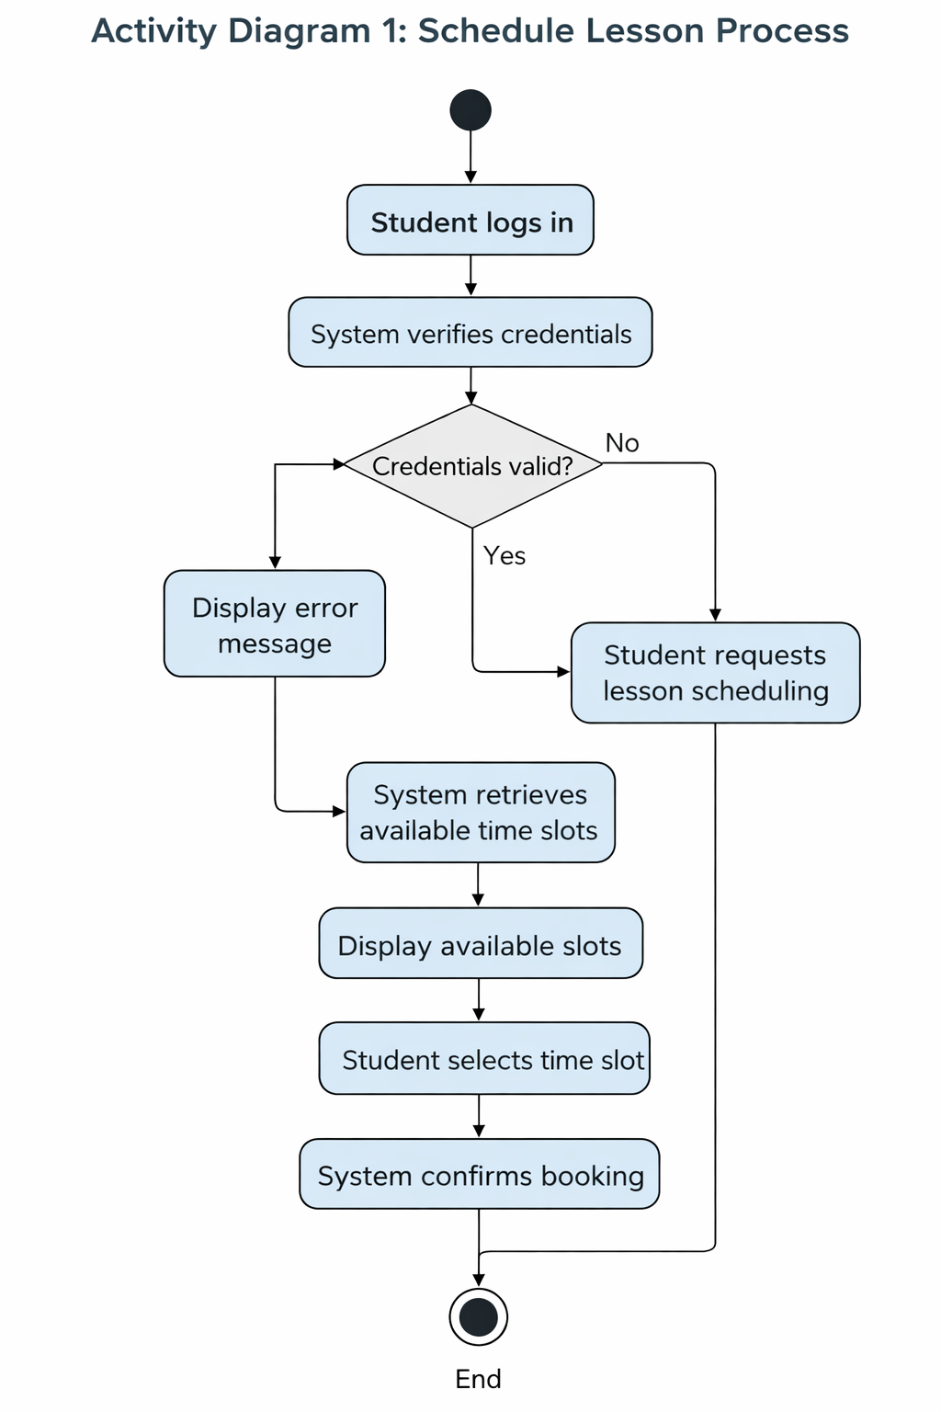

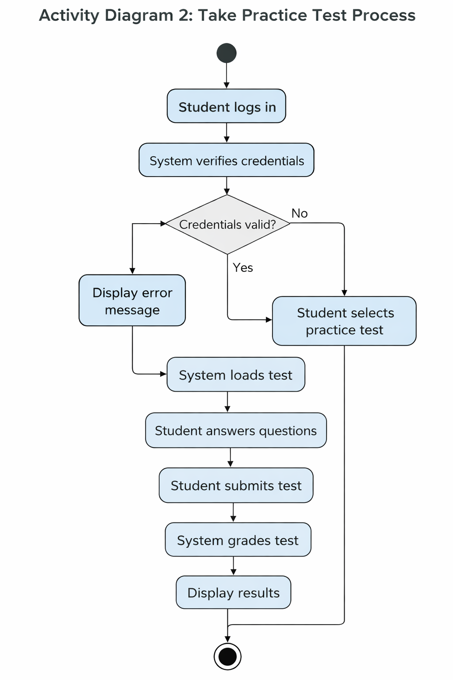

UML Sequence Diagram: Schedule Lesson Interaction

UML Class Diagram
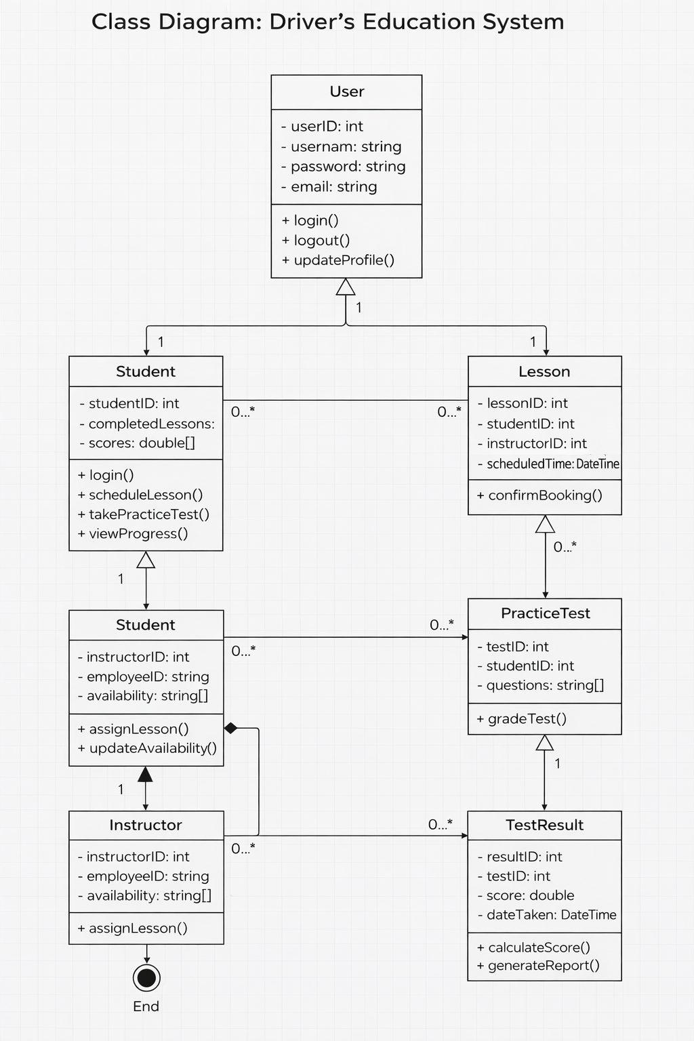

Technical Requirements

The DriverPass system will be delivered as a secure, web-based application that students, instructors, and administrators can access from a computer, tablet, or mobile device. The system must support user account management, lesson scheduling, practice tests, reporting, and administrative maintenance while protecting sensitive user information.

Hardware Requirements
- A cloud-hosted server environment to run the DriverPass application and support multiple users at the same time.
- End-user devices such as laptops, desktops, tablets, or smartphones for students and instructors.
- Administrative workstations for staff who manage users, packages, and reporting.
- Reliable internet connectivity for all users to access scheduling, practice tests, and account features.

Software Requirements
- A web application platform (browser-based) so users can access DriverPass without installing special software.
- A backend application server to handle authentication, scheduling logic, practice test delivery, and report generation.
- A relational database system (such as MySQL or PostgreSQL) to store user accounts, lesson schedules, packages, practice test questions, and results.
- Integration support for external data updates from the DMV so practice tests reflect current driving exam requirements.
- A notification capability (email and/or SMS) to send confirmations for account actions and scheduled lessons.

Security Requirements
- Secure authentication (username/password) with encrypted password storage and role-based access control for Student, Instructor, and Administrator permissions.
- Encrypted data transmission using HTTPS to protect user logins and personal data while in transit.
- Secure handling of sensitive information such as student profile data and any payment-related details.
- Audit-friendly logging for key actions (logins, scheduling changes, administrative updates) to support troubleshooting and accountability.

Tools and Infrastructure Requirements
- A hosting environment with routine backups to protect system data and support recovery in case of failure.
- Basic monitoring to ensure availability and identify outages or performance issues.
- Use of development and documentation tools such as Lucidchart for UML diagrams and a version control system (such as Git) for managing system updates during implementation.

